Version 0.2.0

Password Generator & Storage

External User Manual

Jye Clark [Developer]

Launching The Program

To launch the program you must fit within the following criteria:

* Windows 7, 10 or 11 Operating System.
* Display Resolution of 1536x864, 1920x1080 or 2560x1440.
* Java installed: Version 11 or above. [https://www.oracle.com/java/technologies/javase/jdk19-archive-downloads.html]

If you meet the above criteria, open the .**jar file** located in the program’s directory.

**Hint:** Double CLICK the file named “Password Generator.jar” or RIGHT CLICK, open with Java

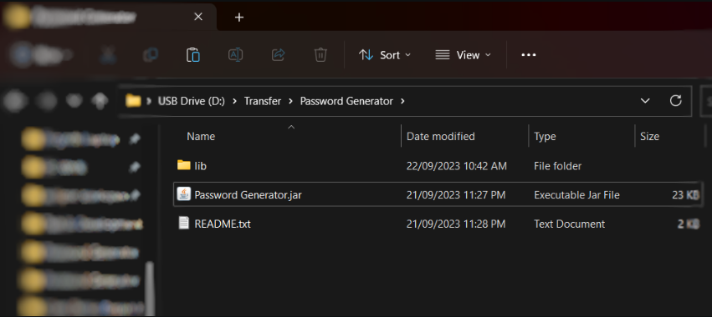

Navigating Menus

Navigation is done with mouse inputs. The keyboard is not needed for this app.

Clicking a button that is displayed within the window will trigger an action.

**Example:** CLICKING the “Generate” button will generate you an entirely new password

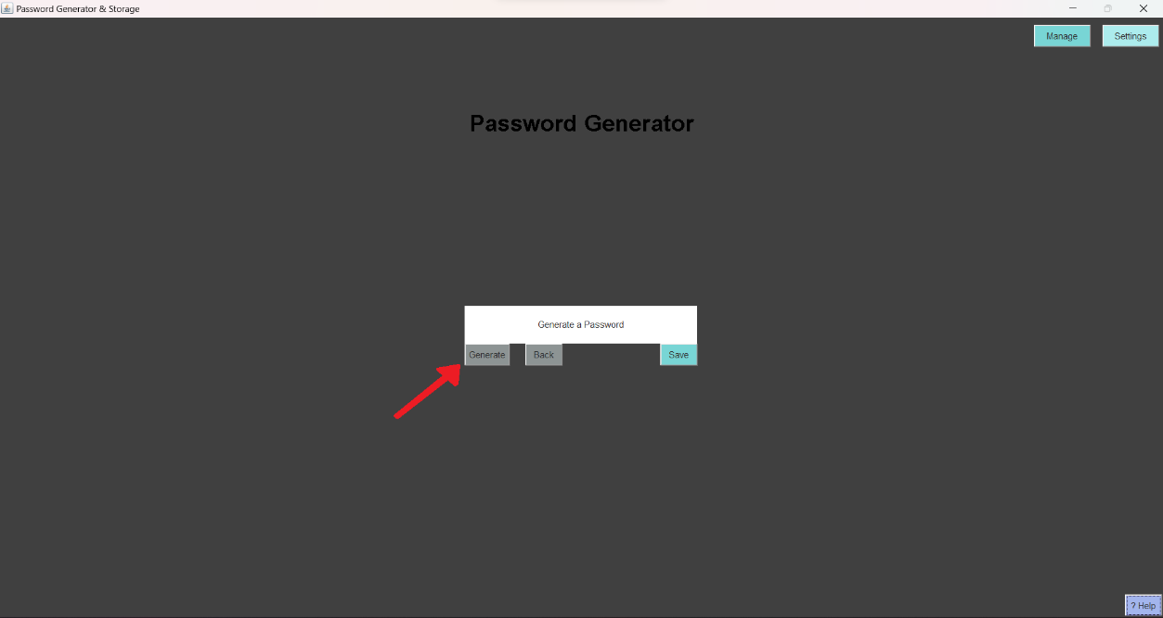

Help Panel

The help panel can be accessed within the app from any menu.

Opening the panel will display some useful information including:

* Brief guide of how to use the app.
* App limitations.
* Total saved passwords.
* How passwords are generated.

**Hint:** The help panel can always be found in the bottom right corner

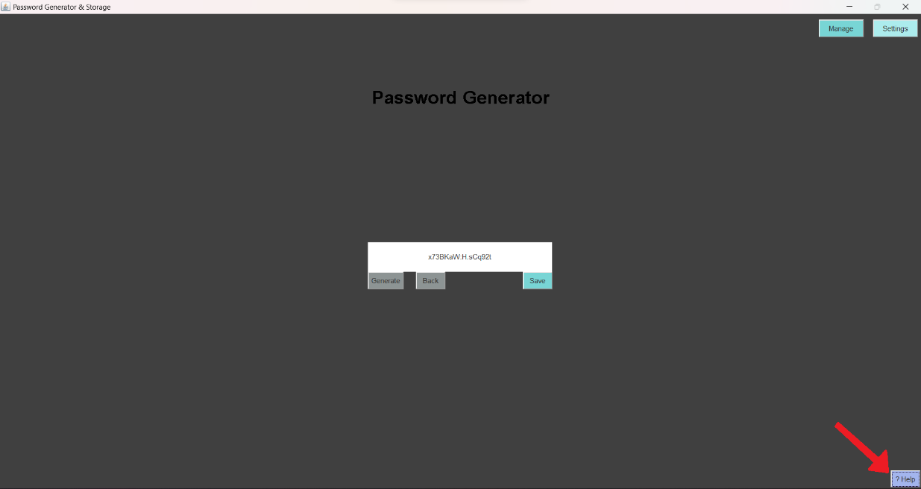

Switching Menus

Whenever you launch the program, you’ll always start on the Generate Menu.

The app has multiple menus. Each is used for a different purpose.

Menus included in the app:

* Generate Menu.
* Manage Menu.
* Settings Menu.

**Hint:** The menu navigation buttons can always be found in the top right corner

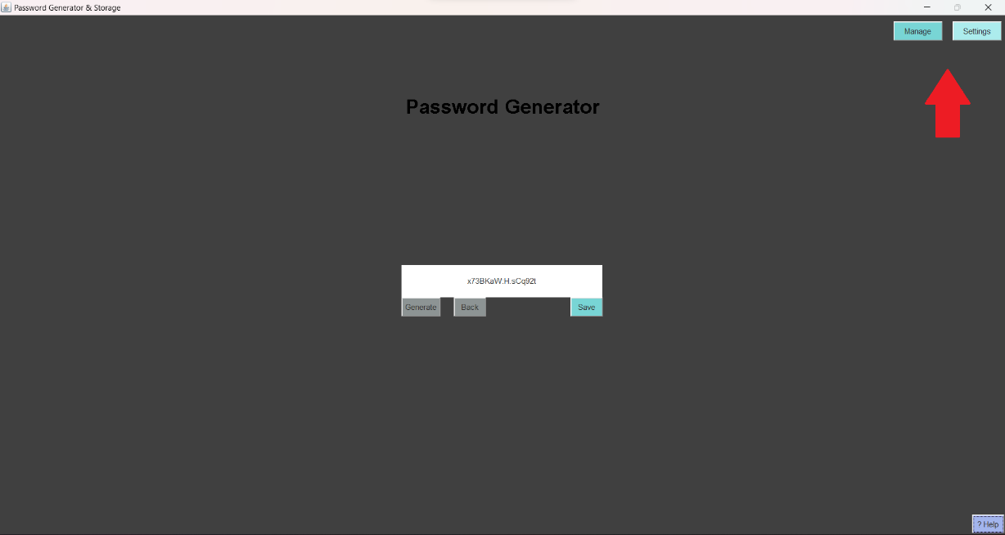

Verifying & Restoring Files

When the program launches it will automatically verify the files within the “**lib**” folder. The files stored in the “**lib**” folder are needed for the program to run.

Information such as **settings data & encrypted passwords** are stored there.

It is important that these files are **not tampered with**, to ensure the program runs smoothly and doesn’t run into issues. You should **not** modify or relocate the files. Doing so may require the program to automatically restore your files which resets everything to default.

You can **manually verify** the files within the settings menu by clicking the “Restore” button.

**Hint:** It’ll be the orange button next to “App Data”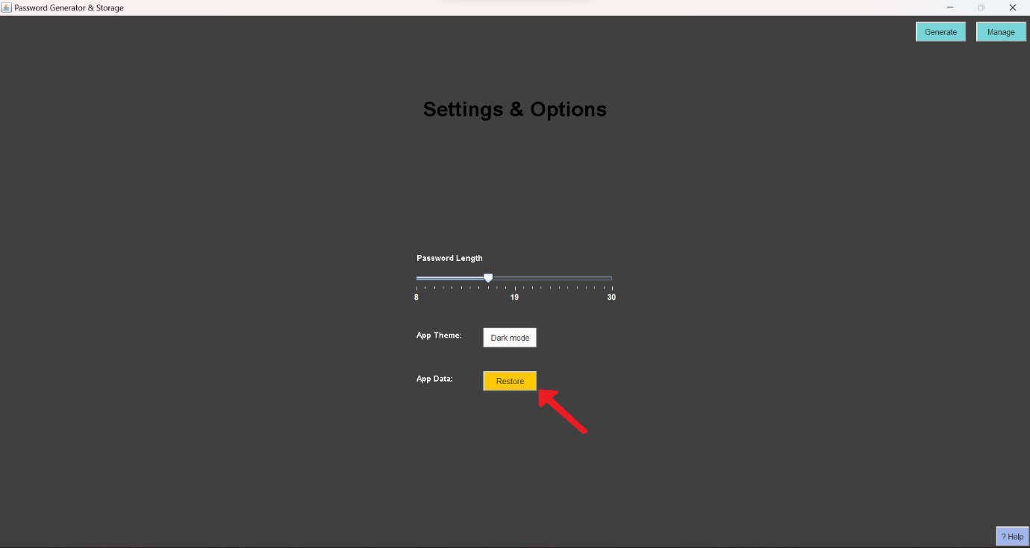

If the program **fails to verify or restore** files, a **full re-install** of the program may be needed.

Uninstalling The Program

There are 2 ways of uninstalling the program:

To uninstall the program entirely and **remove all data** follow the steps below:

1. Locate the directory of the program.

**Hint:** It should look something like this



1. Delete **all files** within this folder (or delete the folder)

To uninstall the program and **keep your data** please delete all files **EXCLUDING** your “**lib”** folder.

If you re-install the program later,

on the same computer please **replace** your new “**lib**” folder with your **existing** one.

Note: Deleting the program will make your saved passwords